Without cloud governance model Bintoso will face many problems. 4 key risks without cloud governance for Bintoso are given below:
- Security risks
- Account sprawl
- Compliance
- Cost overruns

Virtual Structure:
CCOE is not a permanent structure, but instead a virtual team consisting of people from different functions such as Engineering, Operations, Finance, Business, and Security. CCOE gets its sponsorship from a C-level leader typically CIO or CTO. CCOE will ensure adherence to all of your organizational policies through tooling and automation. These policies scan across security and compliance, cost management, and other areas.

CCOE Structure:
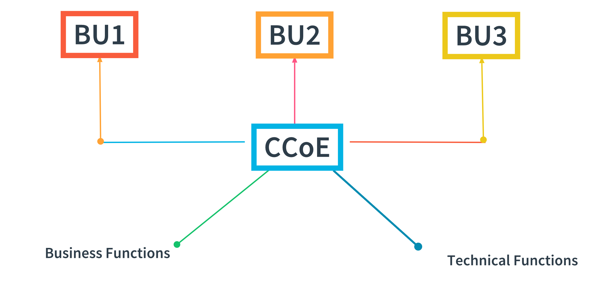
In the image above we can see, the CCOE characteristically perform their jobs outside the (B)usiness (U)nits and delivers its services to multiple BUs. For instance, a consumer durable manufacturing company such as LG or Samsung may have separate BUs for refrigerators, washing machines, televisions, etc. In addition to an enterprise-wide central IT organization, each BU may have its own specific IT organization.

CCOE for Security risks

Security governance can be thought of a 3-layer model and CCOE can address these problems in the following way:
- Infrastructure security: Infrastructure security is owned by the cloud provider. This includes securing compute, storage, and network resources. Defining and applying corporate security standards in all aspects of the IT architecture and ongoing operational support is another key task of CCOE.
- Application security: Application security includes application-specific security controls and data classification. We earlier talked about DevSecOps as a culture that fundamentally resides in this layer. This layer is supported by platform security
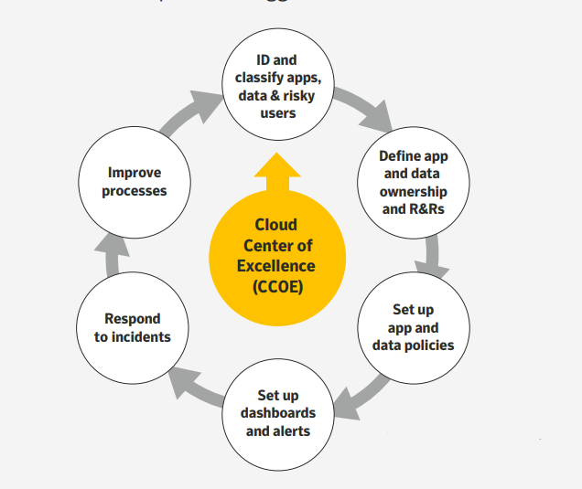
Figure: Cloud application governance lifecycle
This figure describes how to use appropriate project management principles to set up and support your organization’s CCoE which will then define, execute, and document your cloud governance plan.

- Platform Security: Platform Security as the middle layer, if done right can make things much simpler for DevOps teams. This layer includes initial controls such as identity and access management, logging, auditing, automated response, and remediation. We know from the CCOE functions that this is one of the areas where CCOE can help by providing code, templates, tooling, and other assets. The more we can abstract from application teams in terms of foundational controls as well as common patterns we see across applications, the faster the application teams move. This middle layer is typically owned by the central cloud engineering team.
Guardrails:
A comprehensive set of guardrails can be implemented with help from the security team, but here are a few common ones:
- Prevent storage bucket public access - by automatically making it private or warning user when he accidentally creates a bucket with public access
- Secret keys in code - warn users and ask them to put secrets in vaults provided by cloud provider
- Configuration changes - e.g. changed security group settings that may open up internet ingress

